Lab: Chocolate Density!
Introductory Paragraph: Density is the term used to describe the relationship between the mass of an object and its volume. Under constant conditions of temperature and pressure, the density of any substance is always constant. Gold has a density of 19.3 g/cm3, the average rock has a density of 3 g/cm3, and water has a density of 1 g/mL. 1 g/mL means that 1 mL (or cm3) of water has a mass of 1 gram. In this lab, you will be finding the density of a Hershey’s chocolate bar. The density of substances can be determined by measuring its mass and volume and using the following equation:
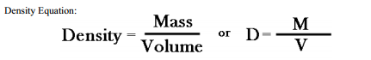

Question: How does the volume of a chocolate bar affect its density? (Does breaking a chocolate bar into pieces affect its density?)
Hypothesis: Record your hypothesis as an “If…., then…” statement on your lab sheet.
Procedure:
- DO NOT eat the candy until ALL of your mass and volume measurements have been completed and recorded in the data table!
- Unwrap your candy bar without breaking it. It is very important that it remain in one piece for the beginning of the activity.
- Using the digital balance, determine the mass of the whole candy bar. For sanitary purposes place the candy bar wrapper between the chocolate bar and the balance pan for ALL measurements. Be sure to zero the balance after placing the wrapper on the balance pan.
- Record the mass (to the nearest tenth of a gram) of the whole Hershey Bar in proper location of the data table.
- Find the volume of the whole Hershey Bar using a metric ruler and the equation for the volume of a rectangular solid: v = l x w x h. Where v = volume, l = length, w = width, and h = height. Record these measurements (to the nearest tenth) in the data table.
- Calculate the density (to the nearest tenth) of the whole Hershey Bar using the density equation.
- Record the density of the whole Hershey Bar in the proper location of the data table. Enter your density into the class spreadsheet.
- Carefully break the whole Hershey Bar along the center indentation.

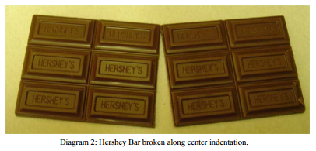
- Calculate the density for one half (6 squares) of the Hershey Bar using procedures 3 through 6 from above. Set the other 6 squares aside.
- Record your answer in the data table to the nearest tenth. Enter your density on the class spreadsheet.
- Carefully break the one half along its center indentation (diagram 3) so that you now have 2 quarters of the original bar. Set one of the quarters aside.
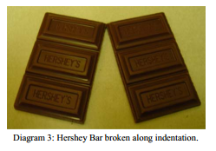
- Calculate the density for one quarter (3 squares) using procedures 3 through 6.
- Record your answer (to the nearest tenth) in the proper location of the data table.
- Enter your density on the class spreadsheet.
- Carefully break one quarter into thirds along the indentations (see diagram 4)
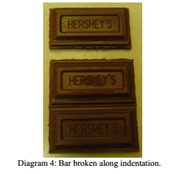
- Calculate the density of the small piece of the Hershey Bar using procedures 3 through 6.
- Record your answer in the data table to the nearest tenth. Enter your data on the class spreadsheet.
Lab: Chocolate Density!

Hypothesis: ______________________________________________________________
___________________________________________________________________________
___________________________________________________________________________
___________________________________________________________________________
___________________________________________________________________________

Data:
Mass of Candy  (to the nearest .1 g) | Length of Candy (to the nearest .1 cm) | Width of Candy (to the nearest .1 cm) | Height of Candy  (to the nearest .1 cm) | Volume of Candy  (to the nearest .1 cm³) | Density of Candy  (to the nearest .1 g/cm³)
Whole Bar

Half Bar

Quarter Bar

Twelfth Bar

Data Table:

1.81.71.61.51.41.31.21.11.00.90.80.70.60.50.40.30.20.1

Density (g/cm³)
Whole Half Quarter Twelfth

Chocolate Bar
Conclusion:

- Compare the overall density of the whole block to the density of 1/12th of the bar.

 | Whole Bar | 1/12th Bar
Density

Was the density significantly different (if the difference is less than .2 g/cm³, then we should assume that it’s the same) ____________

- Compare the overall density of each of the different bar sizes.

 | Whole Bar | Half Bar | 1/4th Bar | 1/12th Bar
Density

Are the numbers for the density of each of the bar sizes similar? Or are they significantly different? _________________________

WHY do you think this might be the case? ________________________________________________________________________________________________________________________________________________________________________________________________________________________________________________________________________

- Using the density of each size bar above, below, draw a diagram of what 1 cm³ would look like if you were to look inside at one of the particles of each bar (assume that each box below is 1 cm³ of space).

Whole Bar Half Bar 1/4th Bar 1/12th Bar

- Now, based on the data that you compared above and the drawings of density, did the volume of the chocolate bar affect its density? Give evidence from your data table to support your conclusion. ________________________________________________________________________________________________________________________________________________________________________________________________________________________________________________________________________________________________________________________________________________________________________________________________________________________________________________________________________________________________________________________________________________________________________________________________________________________________________________________________________________________________________________________________________________________________________________________________________________________

